**Department of Computer Science**

Mid Term Project Proposal, Spring 2020-2021

|  |  |  |  |
| --- | --- | --- | --- |
| Course Title | Web Technology | Section | C |

**Group Members:**

|  |  |  |
| --- | --- | --- |
| Student ID | Name | Signature |
| 18-37864-2 | Mahiul Alam Sad |  |
| 18-38013-2 | Shionty Ghosh Dola |  |
| 18-38045-2 | Sohelee Sen |  |
| 18-37994-2 | Arif Ahmed |  |

**Project Title:**

|  |
| --- |
| Restaurant Management System |

**Short Description:**

|  |
| --- |
| Four type of user: 1. Admin 2. Employee 3. Customers 4.Delivery_man  Common Features for all user:  1.All users can Login to the system  Admin User Functionality:  1. Can add Employee/Admin.  2. Can block(Delete) all user  3. Can manipulate all user information/Add (edit-delete-view etc.)  4. Admin Information form(Registration)  Employee’s:  1. Can Registration(View)  1. Can add product / Can edit product information(edit-delete-view)  3. Can contact system admin etc  Customers:  1. Can Registration(View-Edit-Delete)  1. Can buy product  2. Can comment or provide review  4. Can make a payment  Delivery man:  1. Can Registration(View)  2. Take payments/confirm  3. Can view customer. |

**Introduction:** We all know that in the restaurant industry,

the management of time is extremely important for business purpose. As we live in a very modern world, the use of software and technology is more essential to helping us smooth and shorten the time to takes us to carry out tasks more easy way. This is the main reason to build up this kind of software. Moreover Customer doesn’t need to come physically in the restaurant, they can order from home by this system. It’s help boosting customer also automatic payment method that help user so much. And mostly system will have some value features like coupons and some gift option that make people’s interest on this type of software. Moreover this system is so much easy to use. And finally it helps manage maximize profits, reduce costs also mismanagement and provide an exceptional customer experience.

**Background Study:**

Reference link’s: <https://rmagazine.com/articles/the-importance-of-restaurant-management-software-why-you-need-it.html>

<https://www.posist.com/restaurant-times/singapore/restaurant-management-system-singapore.html>

<https://hubworks.com/blog/restaurant-management-software.html>

**Design:**

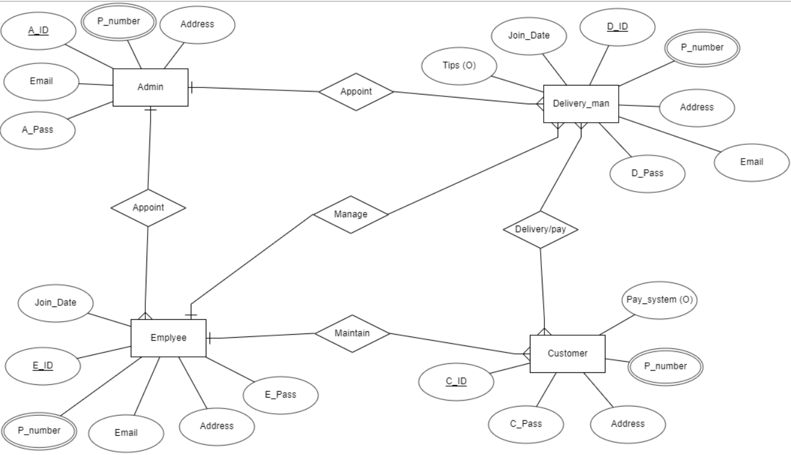

**Tools:** ERDPlus, Photoshop cc

**System Images Against the Specification:**

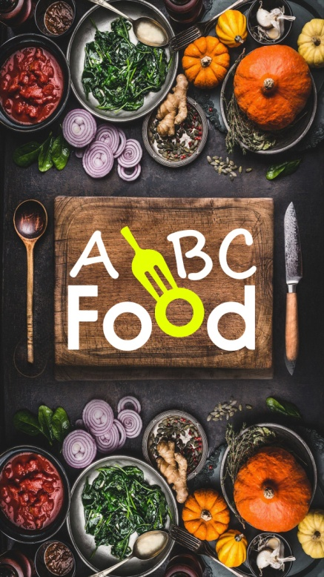 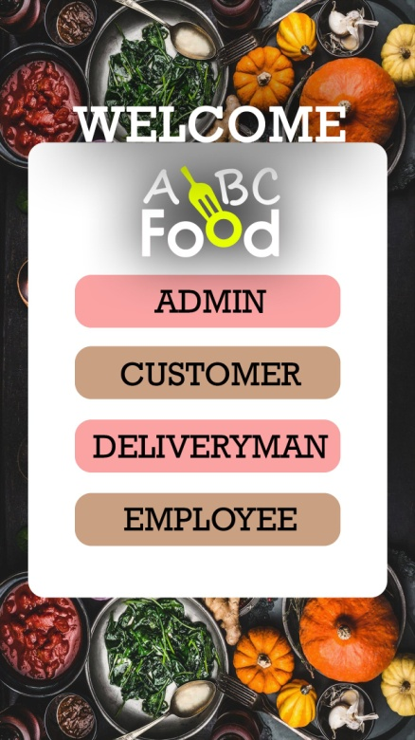 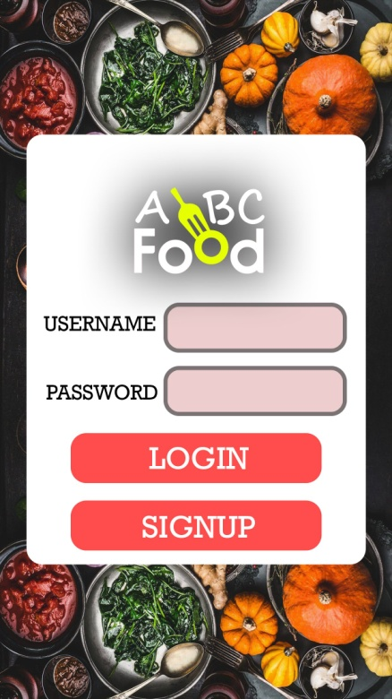

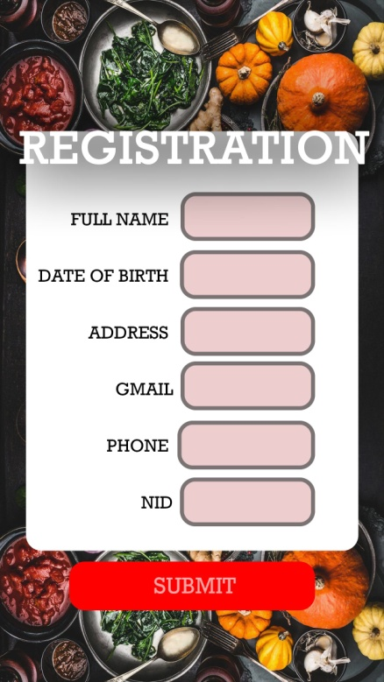 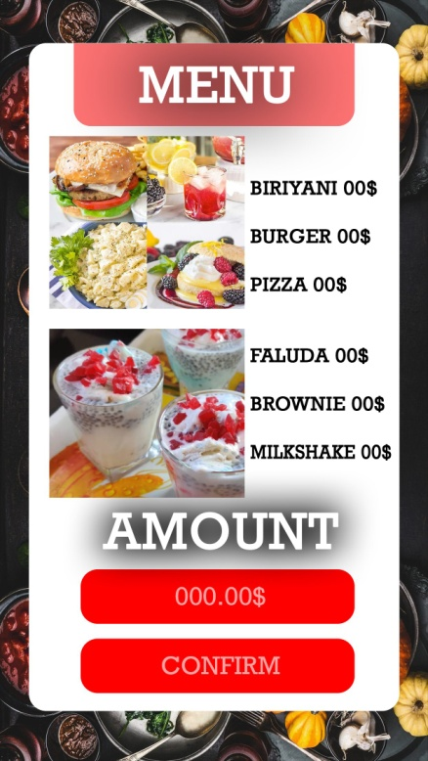 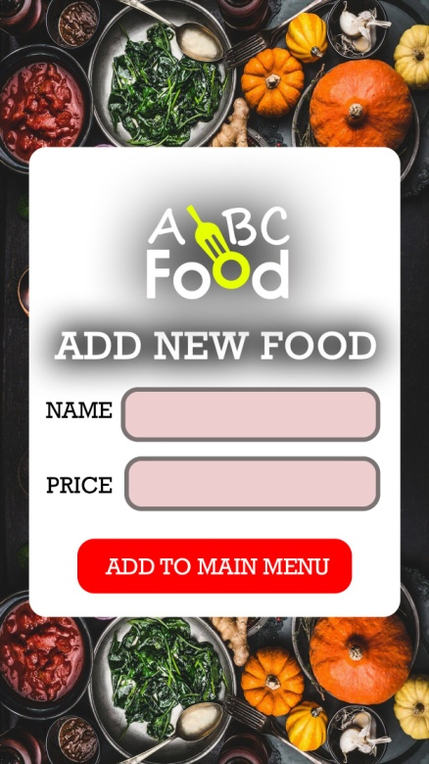

**Impact of this Project:**

An online food ordering and delivery system provides a full sales channel for the restaurant. That means that the restaurant can use it as a tool for generating more profits and organizing the restaurant better. It also allows restaurant owners plenty off to avoid wasting. Many on labor costs and restaurant space needed to serve such customers. When properly implemented, the system can help a restaurant bypass its competition by getting closer to the consumers. An online ordering system is additionally a perfect alternative to 3rd party food aggregators or marketplaces. When a customer visits the platform, they explore different types of foods. That might well be beneficial to the patrons because they'll explore foods in one place instead of going multiple restaurant. However, the marketplace finally lands up in increased costs on the component of the restaurant through commissions and other charges. a web ordering system allows you to limit the worth of commission related to food marketplaces and payment companies.

Limitations and Possible Future Improvements:

1. Deliverymen put themselves in peril

Whether it is a wave boiling down the town or it's snowing or raining heavily, a deliveryman is waiting outside the restaurant to pick out and deliver your order. Although we get the joys of our favourite food in any season, they're also humans who forget their human rights putting themselves in danger sometimes.

1. Disguised increased expense

We surely get attracted by yummy-looking food’s pictures on the app and a tiny low but highlighting banner of cash back offer. However, we forget that despite cash back, it's costing us over the food which we are ready to cook with the groceries available using all our magical cooking skills and spend blindly ordering the food online.

1. Revenue conflicts between the restaurants and delivery providers

Not every restaurant owner can afford to use ten delivery boys and bear all the transport and remuneration expenditure; so, they favor to contract with the delivery service providers through these apps. However, despite automation in place, one can’t control everything through an automatic system and conflicts occur between the restaurant owner and delivery providers regarding the payments.

1. Juggling along with your health

Another disadvantage of online ordering system for your restaurant is while once you attend a restaurant you won’t be seeing the material they use therein mouth-watering Pasta dish that they carry at your table, still, you will be ready to savvy replaced if you discover any faults. However, you're again not visiting know what they use, but you won’t be able to catch on changed or sense any faults in it. Also, due to the pressure of meeting up all the deliveries, the restaurants heat it up so quick that it kills most the nutrients of the food you eat. Moreover, many cases are noted where those that consume this type of food, face health issues like sickness and consuming on an everyday basis, causes you to obese yet.